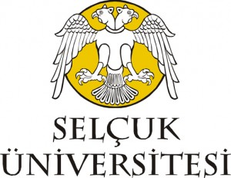
Selçuk University
Erasmus+ Coordination Office
Tel: +90 332 223 4461 & Fax: +90 332 2414082
erasmus@selcuk.edu.tr
www.selcuk.edu.tr

CERTIFICATE OF ATTENDANCE

We hereby confirm that the mentioned staff from University of Selçuk successfully accomplished the Erasmus+ staff mobility for training.
Sending Institution: SELCUK UNIVERSITY (TR KONYA01)
Name-Surname:
Department/Faculty:
From(Day/Month/Year):
To (Day/Month/Year):
Name of the Host Institution:
Name of Authorised person and Function at Host Institution:

Date:

SIGNATURE & STAMP

